Computer Language Coding Concepts

Command References in a Command Reference in a Diagram
Command references in a command reference have been conceptually explained in the article Command References in a Command References.

This article only illustrates how command references in a command reference look in a diagram.

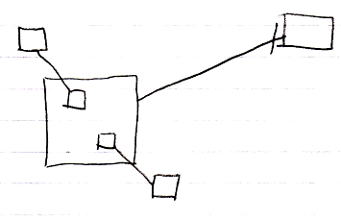

The larger square on the left is a command reference. The target of the command reference is the square on the right, a command definition. The larger square on the left, contains again two command references, smaller squares, that are connected to their reference targets on the outside of the larger command reference.

See also: Command References in a Command Reference,
Creation Behavior of Command Calls in a Diagram

Author & Copyright: Jan-Joost van Zon Date: August 9, 2008 – August 9, 2008 Location: Oosterhout, The Netherlands Status: Under Construction | Finished

